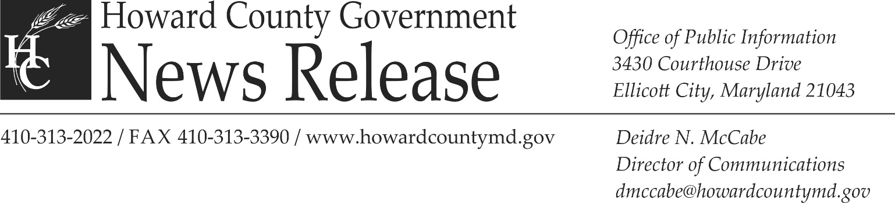

August 26, 2015

Media Contacts:
Deidre McCabe, Director of Communications, Office of Public Information, 410-313-2022
Reverend Dr. Barbara J. Sands, Administrator, Office of Human Rights, 410-313-6430

Howard County Office of Human Rights to present four additional screenings of the award-winning documentary, “The New Black”

ELICOTT CITY, MD – Howard County’s Office of Human Rights has partnered with PFLAG, (Parents, Families and Friends of Lesbians and Gays) Columbia-Howard County chapter, the Maryland Commission on Civil Rights and Promised Land Film to host four additional community showings of the award-winning documentary, “The New Black.”

Directed, produced and written by Yoruba Richen, “The New Black” tells the story of the historic fight to win marriage equality in Maryland and charts the evolution of this divisive issue within the black community. The film has been honored by a number of national film festivals, including AFI Docs, UrbanWorld Film Festival and the Los Angeles Film Festival.

Each screening will begin at 7:00 p.m. and will be followed by a 30-minute audience discussion on the issues raised in the film, facilitated by Office of Human Rights Administrator Reverend Dr. Barbara Sands. The dates and locations of the screenings are as follows:
- Thursday, September 10 at the North Laurel Community Center, 9411 Whiskey Bottom Road in Laurel;
- Thursday, September 17 at The Bain Center, 5470 Ruth Keeton Way in Columbia;
- Thursday, October 15 at the Roger Carter Community Center, 3000 Milltowne Drive in Ellicott City; and
- Thursday, October 29 at the Howard County Library System Central Branch, 10375 Little Patuxent Parkway in Columbia.

Admission to each screening is free and all are invited to attend. For more information about the screenings, contact the Office of Human Rights at 410-313-6430 or email Mary Toth at mtoth@howardcountymd.gov.
###

